My name is **Szymon Sobiepanek**.

I live in **Szczecin, Poland**.

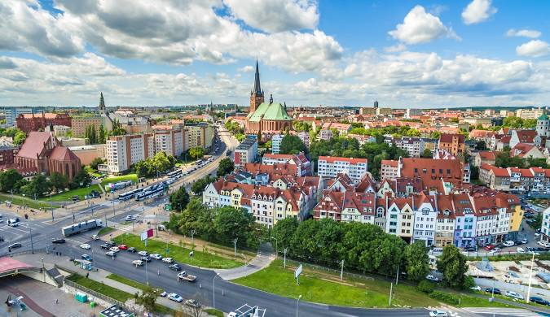

My favorite food is **omelet**.



I like **dancing**.

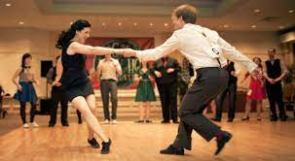

My dream was to come to **Bakrang**.

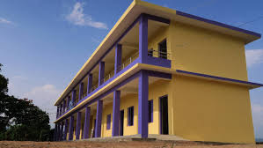

In the future I want to be a **full time teacher**.

